Harbor Lakes Golf Club
Membership Classifications
Social Membership
Dues: Social - $70 each month
Provides access to the clubhouse and dining facilities for the primary member, spouse & any dependents (children age 20 and younger still living at home or attending college)
Provides access to members-only social events
Provides member charge account for sign & go charging privileges
Provides limited golf privileges
(access to putting green, access to driving range for $10 social range fee, access to golf course at Social Member rate.)
Provides reduced room rental fee for use of the banquet room (see event coordinator for full details & restrictions)
Provides $20 discount on birthday entrée during the member’s birthday month
*Social membership requires payment of a non-refundable $1,000 initiation fee at time of joining
(decreased to $100 with signed loyalty agreement)
*Memberships are subject to a food & beverage minimum spend of $65 per month (all purchases of food & beverages both dine-in and carryout count towards minimum)
Golf Membership
Dues: Full Golf without Private Cart - $230 each month
Dues: Individual Golf with Private Cart - $340 each month + $600 annual trail fee
Dues: Family Golf with Private Cart - $390 each month + $600 annual trail fee
Provides access to the clubhouse and dining facilities for the primary member, spouse and any dependents (children age 20 and younger still living at home or attending college)
Provides golf course and golf practice facility access for the primary member (Individual Golf with Private Cart Plan), or for the primary member, spouse, & dependents (Family Plan)
Provides access to members-only tournament and social events
Provides member charge account for sign & go charging privileges
Provides reduced room rental fee for use of the banquet room (see event coordinator for full details & restrictions)
Provides $20.00 off birthday entrée during the member’s birthday month
*Golf membership requires payment of a non-refundable $2,000 initiation fee at time of joining
(decreased to $200 with signed loyalty agreement)
*Private cart memberships require payment of an additional annual private cart trail fee
($600 +/tax, due each January for existing members or pro-rated for new members)
*Memberships are subject to a food & beverage minimum spend of $65 per month (all purchases of food & beverages both dine-in and carryout count towards minimum)
Notes
Members may reserve tee times up to 14 days in advance Locker rental is available (see front desk)
Proper golf attire is required on the course & practice area at all times Proper golf etiquette is expected at all times
Players are permitted to walk during non-peak times Members are required to keep a valid card on file

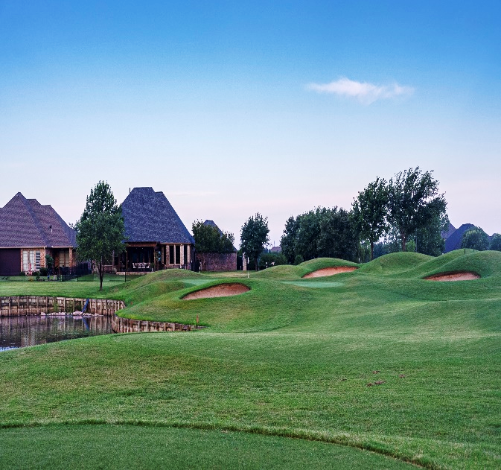
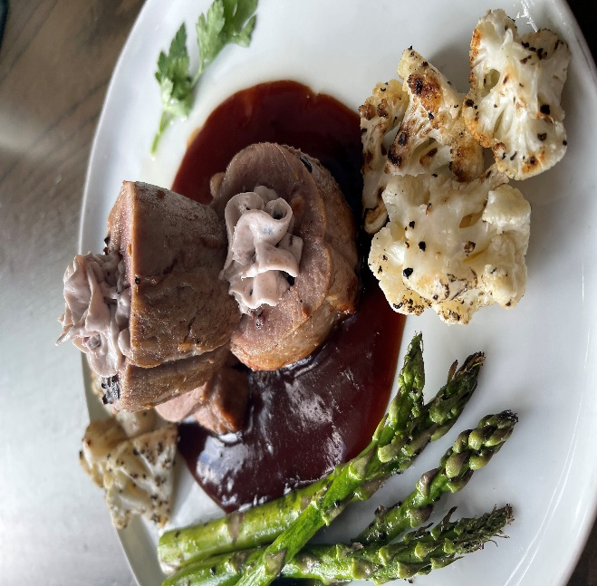
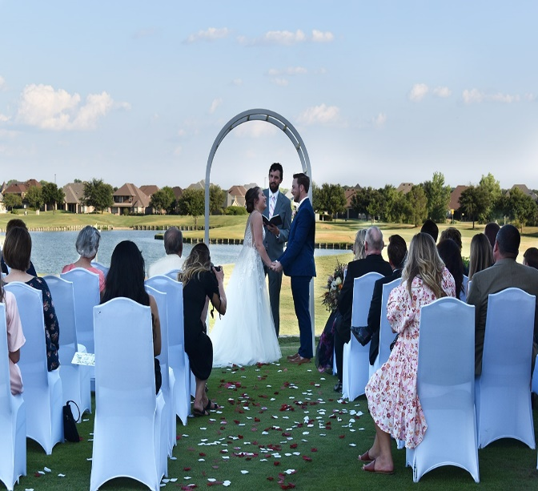
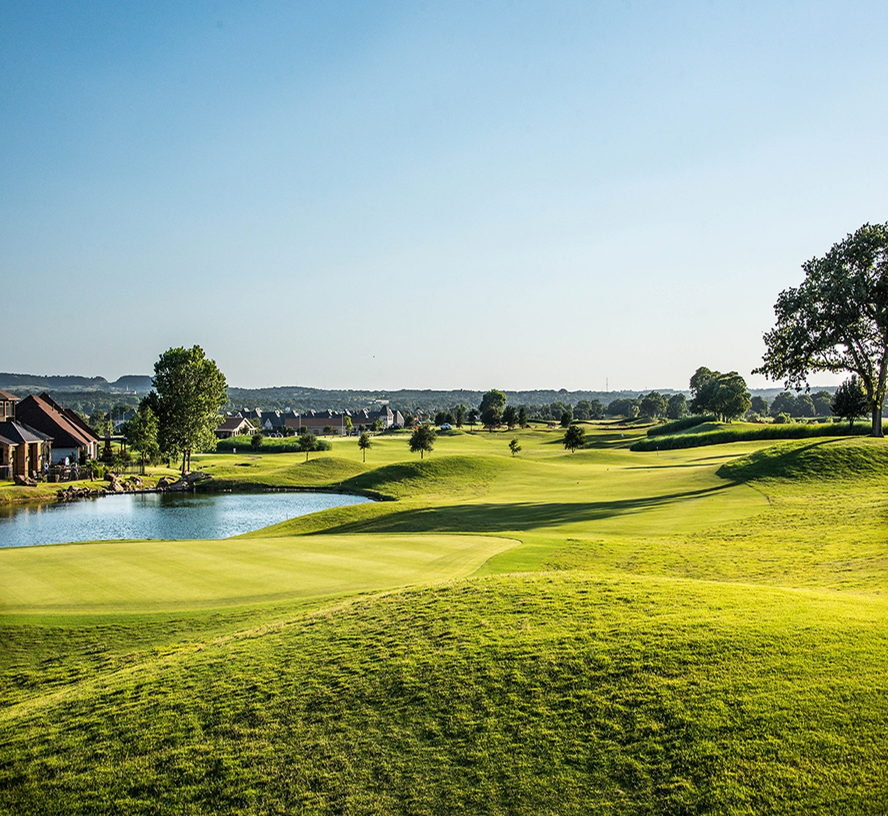
Granbury’s Premier Private Club
Situated on the shores of scenic Lake Granbury, Harbor Lakes Golf Club offers members the opportunity to enjoy the best in championship golf, fine dining, & social activities in a picturesque waterfront setting. Contact us today for more information regarding our membership offers & become a part of our Harbor Lakes Family!
2100 Clubhouse Drive
Granbury, Texas 76048
817-578-8600
membership@harborlakes.com
www.harborlakes.com
DINE
SOCIAL
GOLF

